Swachhata Hi Seva-2018
And
150th Birth Anniversary of Mahatma Gandhi

ICAR-Central Inland Fisheries Research Institute, Barrackpore, Kolkata
Day 14: 02.10.2018
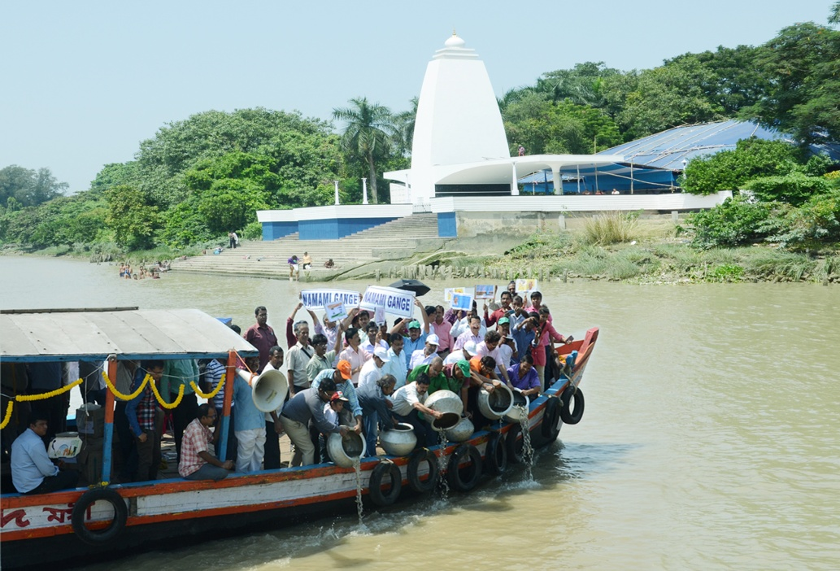
The closing ceremony of Swachhata Hi Seva-2018 was held on 2nd October, 2018, on the occasion of 150th Birth Anniversary of Mahatma Gandhi, Father of the Nation, at ICAR-CIFRI, Barrackpore. The day’s program started with clean Ganga campaign and ranching of major carp seeds in river Ganga near Gandhi Ghat and Sahaid Mangal Pandey Ghat at Barrackpore. Two boats carrying CIFRI staff and guests of the program had cruised the river course displaying banners and by announcing need for keeping ganga clean and importance of Mathama Gandhi’s principles. About 2 lakh fish seeds were released in to the Ganga near Gandhi Ghat and Sahaid Mangal Pandey Ghat at Barrackpore. The guests of the day’s program were Shri. Naveen Nayak, Director, Nehry Yuva Kendra and Shri. Deb Nath Chaterjee, district Youth Coordinator. After the Ganga campaign, the guests along director and Staff of CIFRI inaugurated five wall paintings in the campus depicting importance of cleanliness. Then Institute’s green waste recycling system in the form of wormy compost pits were also inaugurated. The institute has taken a keen initiative to produce vermicompost manure from the organic waste materials like garden waste, leaf litter, kitchen refuge, weed biomass, etc. using mixture of three earth worms namely, Eudrilus eugeniae (Night crawler), Eisenia fetida (Red earthworm) and Perionyx excavates. Two cemented erect beds (Dimension - L x B x H: 12 ft. x 3 ft. x 1 ft) have been constructed which is installed to convert the waste material for producing organic manure. The closing program of Swachhata Hi Seva-2018 and the 150th Birth anniversary of Mahatma Gandhi, was organised in the auditorium of the Institute. The programme was graced by Shri. Navin Nayak, Director Nehru Yuva Kendra, Shri. Debkumar Chatterjee, District Youth Coordinator, Nehru Yuva Kendra and Dr. B. K. Das, Director ICAR-CIFRI. The Heads of the Divisions along with entire CIFRI staff and research scholars were also present on this occasion. The closing programme started the Bhajan “Raghupati Raghava Raja Ram” popularized by Mahatma Gandhi. Dr. V. R. Suresh, Chairman, Swachha Bharat Committe welcomed the gathering with brief introduction of Mahatma Gandhi. Following this, Dr. Ms. Soma Das Sarkar, Scientist ICAR-CIFRI presented a brief report of Swachhata Hi Seva-2018 activities carried out at CIFRI. To ignite the gathering with inspiring story of Gandhiji, Dr. B. K. Das Director, ICAR-CIFRI has delivered a talk on “The Mahatma and the Nation -150 years”. In his speech, Shri Nayak mentioned the prime role of youth for development of the country. Dr. B. P. Mohanty and Dr. U. K. Sarkar HoDs, ICAR –CIFRI have also made their remarks on this occasion. The director has applauded CIFRI staffs for their sincere and laborious voluntary contribution for cleaning the institute premises and outside. In his speech, he also gave a round of applause for the young audience from Nehru Yuva Kendra. Lastly, Ms. Sefali Biswas, Member Secretary, Swachha Bharat Committee has proposed the formal vote of thanks. Ms. Sukanya Som, Scientist ICAR-CIFRI has compared the closing programme of Swachhata Hi Seva-2018. The programme was declared closed with the National Anthem.

